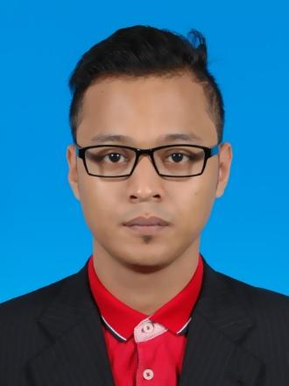**Name:** Muhammad Wafi b. Md Nor

**Address:** No. 108, Lrg Kempas 1,

Kg Melayu Ampang,

68000 Ampang, Selangor

.

**Email:** [WafiMN@gmail.com](mailto:WafiMN@gmail.com)

**Tel (Hp):** 010 - 8618234

|  |
| --- |
| **OBJECTIVES** |

Seek any suitable positions that allow me to serve as a key member in the company or department. Be able to serve my employer with full of commitments, participation and dedications. Last but not least, to gain and seek new knowledge that can helps me to improve my skill.

|  |
| --- |
| **PERSONAL INFORMATION** |

**I.C NO:** 92112714-5263

**NATIONALITY:** MALAYSIAN

**RELIGION:** ISLAM

**RACE:** MALAY

**AGE:** 24

**SEX:** MALE

**MARITAL STATUS:** SINGLE

**DATE OF BIRTH:** 27th November 1992

**HEIGHT:** 179CM

**WEIGHT:** 70KG

**SPONSORSHIP TKWBNS (PINJAMAN KERAJAAN NEGERI SELANGOR)**

**PTPTN**

**LANGUAGE:** PROFICIENT IN MALAY, ENGLISH (BOTH WRITTEN AND SPOKEN)

**AVAILABILITY:** 28th June 2016

**CAREER LEVEL:** INTERNSHIP

|  |
| --- |
| **EDUCATIONAL BACKGROUND** |

**2014-CURRENT** UNIVERSITI TEKNOLOGI MARA (UiTM) SHAH ALAM

BACHELOR IN MECHANICAL ENGINEERING (HONS)

***CGPA: 2.62***

**2010-2013** UNIVERSITI TEKNOLOGI MARA (UiTM)

DIPLOMA IN MECHANICAL ENGINEERING (AEROSPACE),

***CGPA: 2.99***

**2006-2009** SEKOLAH MENENGAH TEKNIK GOMBAK

CIVIL ENGINEERING

***6A 3B 1C***

|  |
| --- |
| **SKILLS** |

**TECHNICAL SKILL: Handle welding process (Shielded metal arc, Welding, Gas Metal Arc welding, Gas Tungsten Arc Welding), Sheet metal machine, Casting –Beginner), Woodwork**

**COMPUTER: Microsoft Office Package, C++ Programming, SolidWork,CATIA, MATLAB VR5**

|  |
| --- |
| **WORK EXPOSURE** |

**1. GOGGLES** **(M) SDN BHD**

***Promoter (January - March, 2010)***

RESPONSIBILITIES

* To help the GOGGLES Company gained more profit by promoting the clothes displayed.

**2. GMIP consultancy**

***Facilitator (August – December, 2013)***

RESPONSIBILTIES

* Conduct charity event in UiTM to raise fund for illiterate pupils in Juru, Penang
* To help a group of people understand their common objectives and assists them to plan how to achieve these objectives.

**3. MICROSOFT Corporation**

***Ambassador (July 2015 – Present)***

RESPONSIBILITIES

* Provide a good knowledge to society about windows phone and Microsoft devices by doing a roadshow.

|  |
| --- |
| **ACHIEVEMENT** |

1. **3rd place in AirBoat CATIA Design Competition** (Mechanical Engineering Design I) at Universiti Teknologi Mara Shah Alam (2015)
2. **3rd place in AirBoat Fabrication and Race Competition** (Mechanical Engineering Design II) at Universiti Teknologi Mara Shah Alam (2015)
3. Medal Bronze in National Mathematics OLIMPIAD (OLIMPIAD Matematik Kebangsaan) 2009

|  |
| --- |
| **REFEREES** |

**Prof Dr Hjh Salmiah Kasolang**

Dean Faculty of Mechanical Engineering

Mara University of Technology (UiTM) Shah Alam

03 – 55435159

**Mr. Khair Izwan B. Khudzari**

Project Senior Executive

Microsoft Corporation

Humanomics

013 – 3369745

Khair@humanomics.com.my